Assignment #1 - Class modelling

Task #1 : System description

Banking - Communication Services System (Email & SMS)

The Banking – Communication Services System is a secure and auditable platform used by a bank to create, schedule, and deliver customer-facing messages through Email and SMS channels.
It supports both transactional messages (account alerts, OTPs, etc.) and marketing campaigns, offering features such as message templating, multi-recipient campaign management, delivery tracking per recipient, retry policies, and full audit logging to satisfy banking compliance requirements.
The system is role-based, allowing different user types - such as customers, bank employees, and administrators - to perform specific actions within their assigned permissions. Its design emphasizes modularity, traceability, and sustainability while ensuring that all communications remain secure, regulated, and measurable in environmental impact.

Core domain classes :
Total = 11 classes + enumeration. The model contains an abstract class, generalization, association class, derived attributes, and qualifiers.

1. User (abstract)
“User” is a generic actor in the system. All user roles inherit from User, so common data like identifiers and contact info are stored once.

Attributes:
- userId: String
- name: String
- surname: String
- emailAddress: String
- phoneNumber: String

2. Customer (inherits User)
“Customer” represents a bank customer who receives messages.

Attributes:
- customerId: String

3. BankStaff (inherits User)
“Bank Staff” prepares and manages campaigns, they are the author of the messages.

Attributes:
- bankStaffId: String
- departmentName: String

4. ChannelAdmin (inherits User)
“Channel Admin” manages the technical configuration of messaging channels ( Email/SMS gateways ).

Attributes:
- channelAdminId: String

5. SystemAdmin (inherits User)
“System Admin” manages system security, roles and audits.

Attributes:
- systemAdminId: String

6. Message (abstract)
“Message” is the generic template for all message types.

Attributes:
- messageId: String
- subject: String
- body: String
- createdAt: DateTime
- scheduledAt: DateTime (nullable)
- status: MessageStatus (enum: DRAFT, SCHEDULED, SENT, DELIVERED, FAILED)
- /deliveryRate: Double

7. EmailMessage (inherits Message)
“Email Message” is the specialisation for emails; supports file attachments.

Attributes:
- attachments: String[]

8. SMSMessage (inherits Message)
“SMS Message” is the specialisation for SMS; derived field counts how many 160-char segments the text occupies.

Attributes:
- /smsParts: Integer

9. Campaign
“Campaign” groups messages under a single marketing or information initiative.

Attributes:
- campaignId: String
- name: String
- startDate: Date
- endDate: Date

10. Delivery (association class between Message and Customer)
“Delivery” represents “each message to customer delivery” event; stores delivery-specific data.

Attributes:
- deliveryId: String
- status: MessageStatus
- attempts: Integer

11. SustainabilityMetric
“Sustainability Metric” records the environmental footprint of a campaign.

Attributes:
- metricId: String
- energyKWh: Double
- co2Kg: Double

Enumeration:
MessageStatus { DRAFT, SCHEDULED, SENT, DELIVERED, FAILED } : defines the life-cycle of any message or delivery.

Derived Data and Business Constraints :

- Derived data:
- Message./deliveryRate = successful deliveries / total deliveries.
- SMSMessage./smsParts = calculated from message length and encoding.

- Constraints:
- Delivery.attempts ≤ 5; after five failures, status = FAILED.
- Only BankStaff can create or schedule campaigns.
- ChannelAdmin may modify channel configurations but cannot edit content.
- SysAdmin manages user roles and security settings.
- Customer can only receive messages, not create them.
- Each Campaign must record its sustainability data for annual reporting.

Roles and Responsibilities :
1. Customer : Receives Email/SMS notifications; interacts passively with messages.
2. BankStaff : Creates Campaigns and Messages; monitors delivery outcomes; ensures compliance.
3. ChannelAdmin : Manages channel configurations and providers; oversees throughput and reliability.
4. SystemAdmin : Controls system settings, roles, and audit processes; ensures regulatory compliance.

Relationships and multiplicities :
Relationship | Multiplicity | Explanation
User → subclasses | 1 generalisation → {Customer, BankStaff, ChannelAdmin, SystemAdmin} | Different user roles in the system
BankStaff → Campaign | 1 staff creates 0..* campaigns | Each campaign has exactly one creator
Campaign → Message | 1 campaign contains 1..* messages | Every campaign includes at least one message
Message → Delivery → Customer | 1 message produces 0..* deliveries / each delivery targets 1 customer | Association class captures per-customer delivery details (status, attempts)
Customer → Message (qualifier) | [messageSeq] qualifier | Each customer’s messages are indexed by a sequential number (messageSeq) for easy audit
Campaign → SustainabilityMetric | 0..1 metric per campaign | Each campaign optionally references its sustainability impact data

Task #2 : Class Model
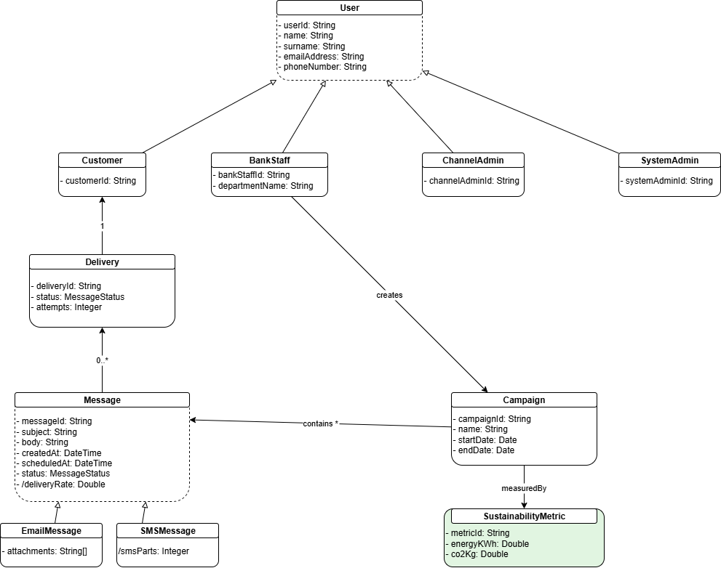

Sustainability Dimension :
The sustainability perspective is integrated at three levels:

- Artifact / Model Level :
The SustainabilityMetric class is explicitly linked to Campaign, storing quantitative data (energyKWh, co2Kg). This allows each campaign’s environmental footprint to be modeled directly.

- Process Level :
When a campaign is executed, the system automatically estimates resource consumption (e.g., power used by SMS/email servers) and stores it in SustainabilityMetric. Reports comparing different channels (SMS vs Email) can guide low-impact choices.

- Application Level :
A dashboard can visualize sustainability trends across all campaigns. High-impact campaigns can trigger optimization alerts for ChannelAdmin or SystemAdmin. Integrating sustainability promotes awareness and aligns the bank’s digital communication with ESG (Environmental, Social & Governance) objectives.

Task #3 : Modelling Environment and Tool Evaluation

The class diagram for the Banking – Communication Services System was designed using draw.io -a free, browser-based visual modelling environment.
Draw.io supports the creation of UML diagrams such as class diagrams, use-case diagrams, and sequence diagrams, and allows exporting models in multiple formats including .drawio, .png, .pdf, and .xml.
The choice of draw.io was motivated by several decisive factors:
- Accessibility and Collaboration :
Draw.io is entirely web-based and does not require installation, making it convenient for remote teamwork. Diagrams can be stored and versioned in Google Drive, OneDrive, or GitHub.
- Ease of Use :
The interface provides drag-and-drop UML shapes and connectors, allowing for fast model construction without steep learning curves.
- Customization and Flexibility :
Custom labels (e.g., for multiplicities, derived attributes /deliveryRate, or qualifiers [messageSeq]) can be easily added, which is critical for accurate class modelling.
- Compatibility and Export Options :
The .drawio format can be converted to PlantUML or XML, making it possible to integrate into other UML tools if deeper modelling or code generation is required later.
- Open Source and Lightweight :
Unlike heavy UML suites such as Enterprise Architect, draw.io is open-source, free, and lightweight, which makes it suitable for academic use.

In conclusion, Draw.io was chosen because it is free, intuitive, collaborative, and flexible, making it ideal for early-stage system modelling.

While draw.io is primarily a diagramming tool, it supports model-to-code transformation indirectly by allowing diagrams to be exported as PlantUML XML files, which can then be processed by external code generation tools such as PlantUML, Visual Paradigm, or GenMyModel.

Although draw.io does not provide native automatic code generation, its compatibility with PlantUML and other export formats enables seamless integration into broader model-driven development workflows. In later project stages, the models designed in draw.io can be migrated into code-centric environments like Visual Paradigm or StarUML to generate Java, Python, or C# class skeletons that reflect the designed structure.

Therefore, draw.io effectively supports the conceptual design phase of the Banking - Communication Services System while maintaining portability and future readiness for code generation and model-based software engineering.

Observations regarding generated code:

- Mapping accuracy:
When exported through the PlantUML format, class names, attributes, and inheritance structures (User, Message, and their subclasses) are preserved correctly.
Associations (e.g., Message → Delivery → Customer) are generated as references or list relationships in the target code.
- Weaknesses:
  - Some UML semantics such as derived attributes (/deliveryRate), qualifiers ([messageSeq]), and association classes (Delivery) are not automatically translated into programming-language constructs.
  - Code generators often omit visibility modifiers or derived field formulas, requiring manual refinement after generation.
- Model–Code alignment:
The overall structure of the generated code matches the class hierarchy and relationships in the designed model, but semantic details (e.g., multiplicities and OCL constraints) need to be re-added in code manually.
- Improvement reflection:
This experiment highlights that model clarity (precise class naming, attributes, and multiplicities) is essential for clean code generation.
Some refinements—like converting derived data into calculated methods—were necessary to make the model implementation-ready.

Task #4 (1 point): Evidence of Team Work

Here is the link of github repository where contribution from both team members are shown.
Link: zeynepkesim/class-modelling: Systems Modelling | Assignment #1 - Class Modelling
OR - https://github.com/zeynepkesim/class-modelling (copy and paste in browser).

Task #5: Exploring and Documenting Generative AI Capabilities in Class Modelling
We used ChatGPT as generative AI to enhance content quality and assistance for draw.io. ChatGPT was chosen because it can understand natural language descriptions of systems and can help to improve the UML models in text-based formats (like PlanUML).
These generating capabilities makes it suitable for experimenting with AI-supported class Diagram generation.
Prompts Used:
- Prompt 1:
Generate a UML class diagram in PlantUML format for a simple banking communication. It must include classes for Customer, BankStaff, ChannelAdmin, and SystemAdmin and Includes attributes, relationships, and multiplicities.
- Prompt 2:
Add derived attributes (/deliveryRate, /smsParts), an association class (Delivery), and a qualifier (Customer → Message [messageSeq]). Verify if the relationships are compatible: Campaign → BankStaff → Message → Delivery → Campaign and Customer → SustainabilityMetric (0..1).
- Prompt 3:
Add inheritance structures to the subclasses of Message and User.
For every association, clearly state the multiplicities and role names.
- Prompt 4:
Refine the model to maintain abstract classes, generalization, enumeration, and qualifiers while adhering to UML syntax and being able to be drawn in PlantUML or Draw.io.

Tool Selection and Justification
Tool: ChatGPT (GPT-5)
Reasoning:
- Language-based Modelling: ChatGPT allows for dialogue-based modelling instead of manual diagramming by converting natural language system descriptions into structured UML syntax (PlantUML or Mermaid).
- Iterative Refinement: Without having to redo the diagrams by hand, the model can be interactively enhanced using prompts.
- Flexibility in Integration: For visualization or additional modification, the produced PlantUML code can be imported into programs such as Draw.io, StarUML, or Visual Paradigm.
- Cost and Accessibility: Without requiring specific UML software, ChatGPT offers free, browser-based AI-assisted modeling.
Comparison and Evaluation:
Aspect | ChatGPT Generated Model | Manually Designed Draw.io Model
Accuracy | Minor syntax error, need human assistance | Accurate to the requirement.
Relationships | All relationships present | Explicit multiplicities drawn visually
Visual clarity | Need to be adjusted by human. | Precisely formatted on draw.io
Speed and Effort | Fast but needs human to fine-tune. | Slower but precise.

Critical Assessment
Strengths of Generative AI Modelling:
- Quick creation of natural language-based models.
- Simple iterative improvement using conversational cues.
- PlantUML exportable syntax for modeling tool integration.
Weaknesses:
- Lacks rigorous UML semantic checking, so that qualifiers and derived characteristics might not always be syntactically correct.
- Does not visualize or apply multiplicity rules automatically.
- Has to be verified by humans in order to comply with project specifications and class semantics.
AI generated class Model (PlantUML Snippet):
@startuml
abstract class User {
- userId : String
- name : String
- surname : String
- emailAddress : String
- phoneNumber : String
}
class Customer {
- customerId : String
}
class BankStaff {
- bankStaffId : String
- departmentName : String
}
class ChannelAdmin {
- channelAdminId : String
}
class SystemAdmin {
- systemAdminId : String
}
abstract class Message {
- messageId : String
- subject : String
- body : String
- createdAt : DateTime
- scheduledAt : DateTime
- status : MessageStatus
- /deliveryRate : Double
}
class EmailMessage {
- attachments : String[]
}
class SMSMessage {
- /smsParts : Integer
}
class Campaign {
- campaignId : String
- name : String
- startDate : Date
- endDate : Date
}
class Delivery {
- deliveryId : String
- status : MessageStatus
- attempts : Integer
}
class SustainabilityMetric {
- metricId : String
- energyKWh : Double
- co2Kg : Double
}
enum MessageStatus {
DRAFT
SCHEDULED
SENT
DELIVERED
FAILED
}
User <|-- Customer
User <|-- BankStaff
User <|-- ChannelAdmin
User <|-- SystemAdmin
Message <|-- EmailMessage
Message <|-- SMSMessage
BankStaff "1" --> "0..*" Campaign : creates >
Campaign "1" --> "1..*" Message : contains >
Message "1" --> "0..*" Delivery : produces >
Delivery "1" --> "1" Customer : targets >
Customer --> Message : [messageSeq]
Campaign "0..1" --> SustainabilityMetric : measures >
@enduml

